CS 255 System Design Document

UML Diagrams

UML Use Case Diagram
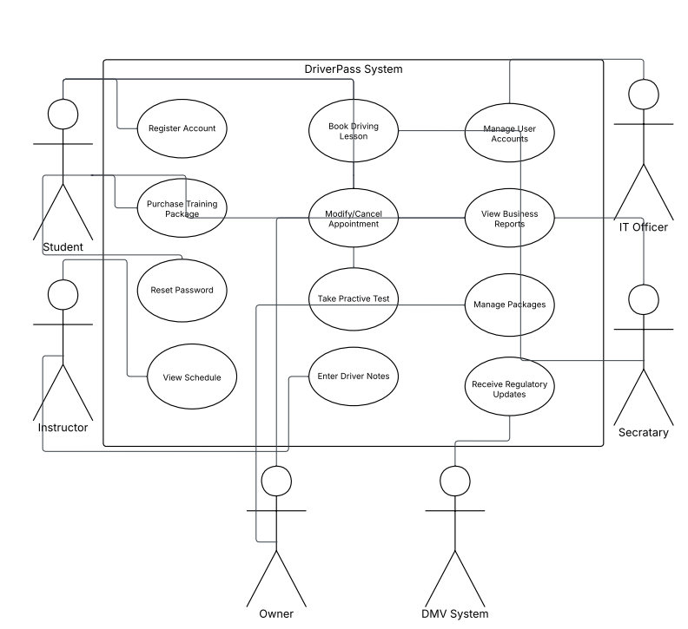

UML Activity Diagrams
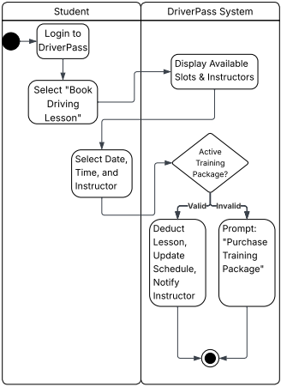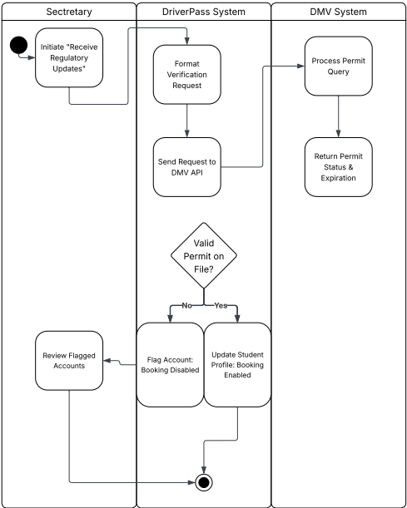

UML Sequence Diagram
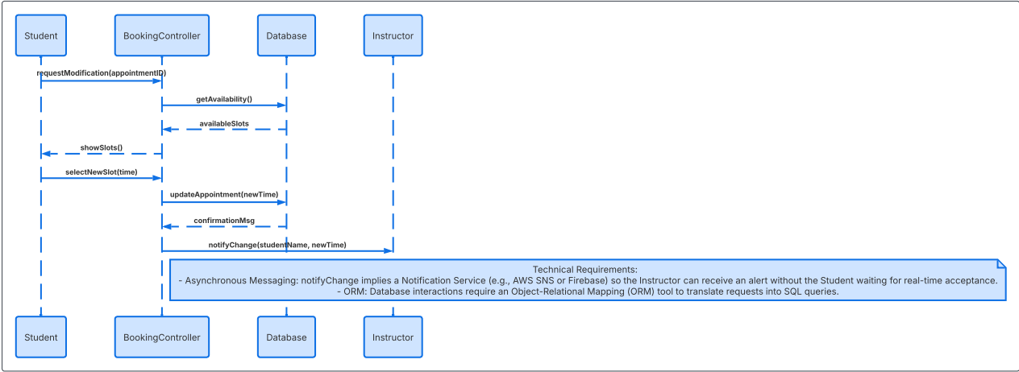

UML Class Diagram
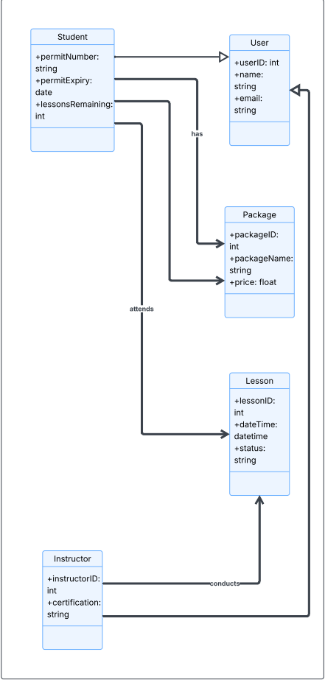

Technical Requirements
The DriverPass system is designed as a cloud-native application to ensure high availability, scalability, and secure remote access for the Owner, Secretary, and Students. Based on the system design, the following requirements are essential:
- Cloud Infrastructure:
  - Hosting: The system must be hosted on a platform like AWS or Microsoft Azure to support a "cloud-based" architecture.
  - Database: A relational database management system (RDBMS) like PostgreSQL is required to manage the complex associations between Students, Lessons, and Packages identified in the Class Diagram.
- Software and Integration:
  - External API Integration: The system requires a secure integration layer to facilitate "Regulatory Updates" by communicating directly with the external DMV System.
  - Frontend: A responsive web application (built with React or Angular) to allow Students to "Register Accounts" and "Book Lessons" from any device.
  - Backend: A robust server-side environment (Node.js or Python) to execute the logic defined in the Activity and Sequence diagrams, such as verifying lesson availability and sending notifications.
- Tools and Security:
  - Notification Service: Integration with an SMTP or Push Notification service is necessary to "notify instructors" and confirm student bookings.
  - Encryption: To protect sensitive student data and DMV records, the system must implement TLS encryption for data in transit and AES-256 for data at rest.
  - Version Control: Git must be used for collaborative development and to track the "schedule planning" tasks effectively throughout the deployment phase.

